Conserving our Trees and Combatting Climate Change

Have you not noticed? Our trees are being overwhelmed and slowly killed by vines. All over Montgomery County. Actually, all over Maryland and the mid-Atlantic region! Here’s the evidence.

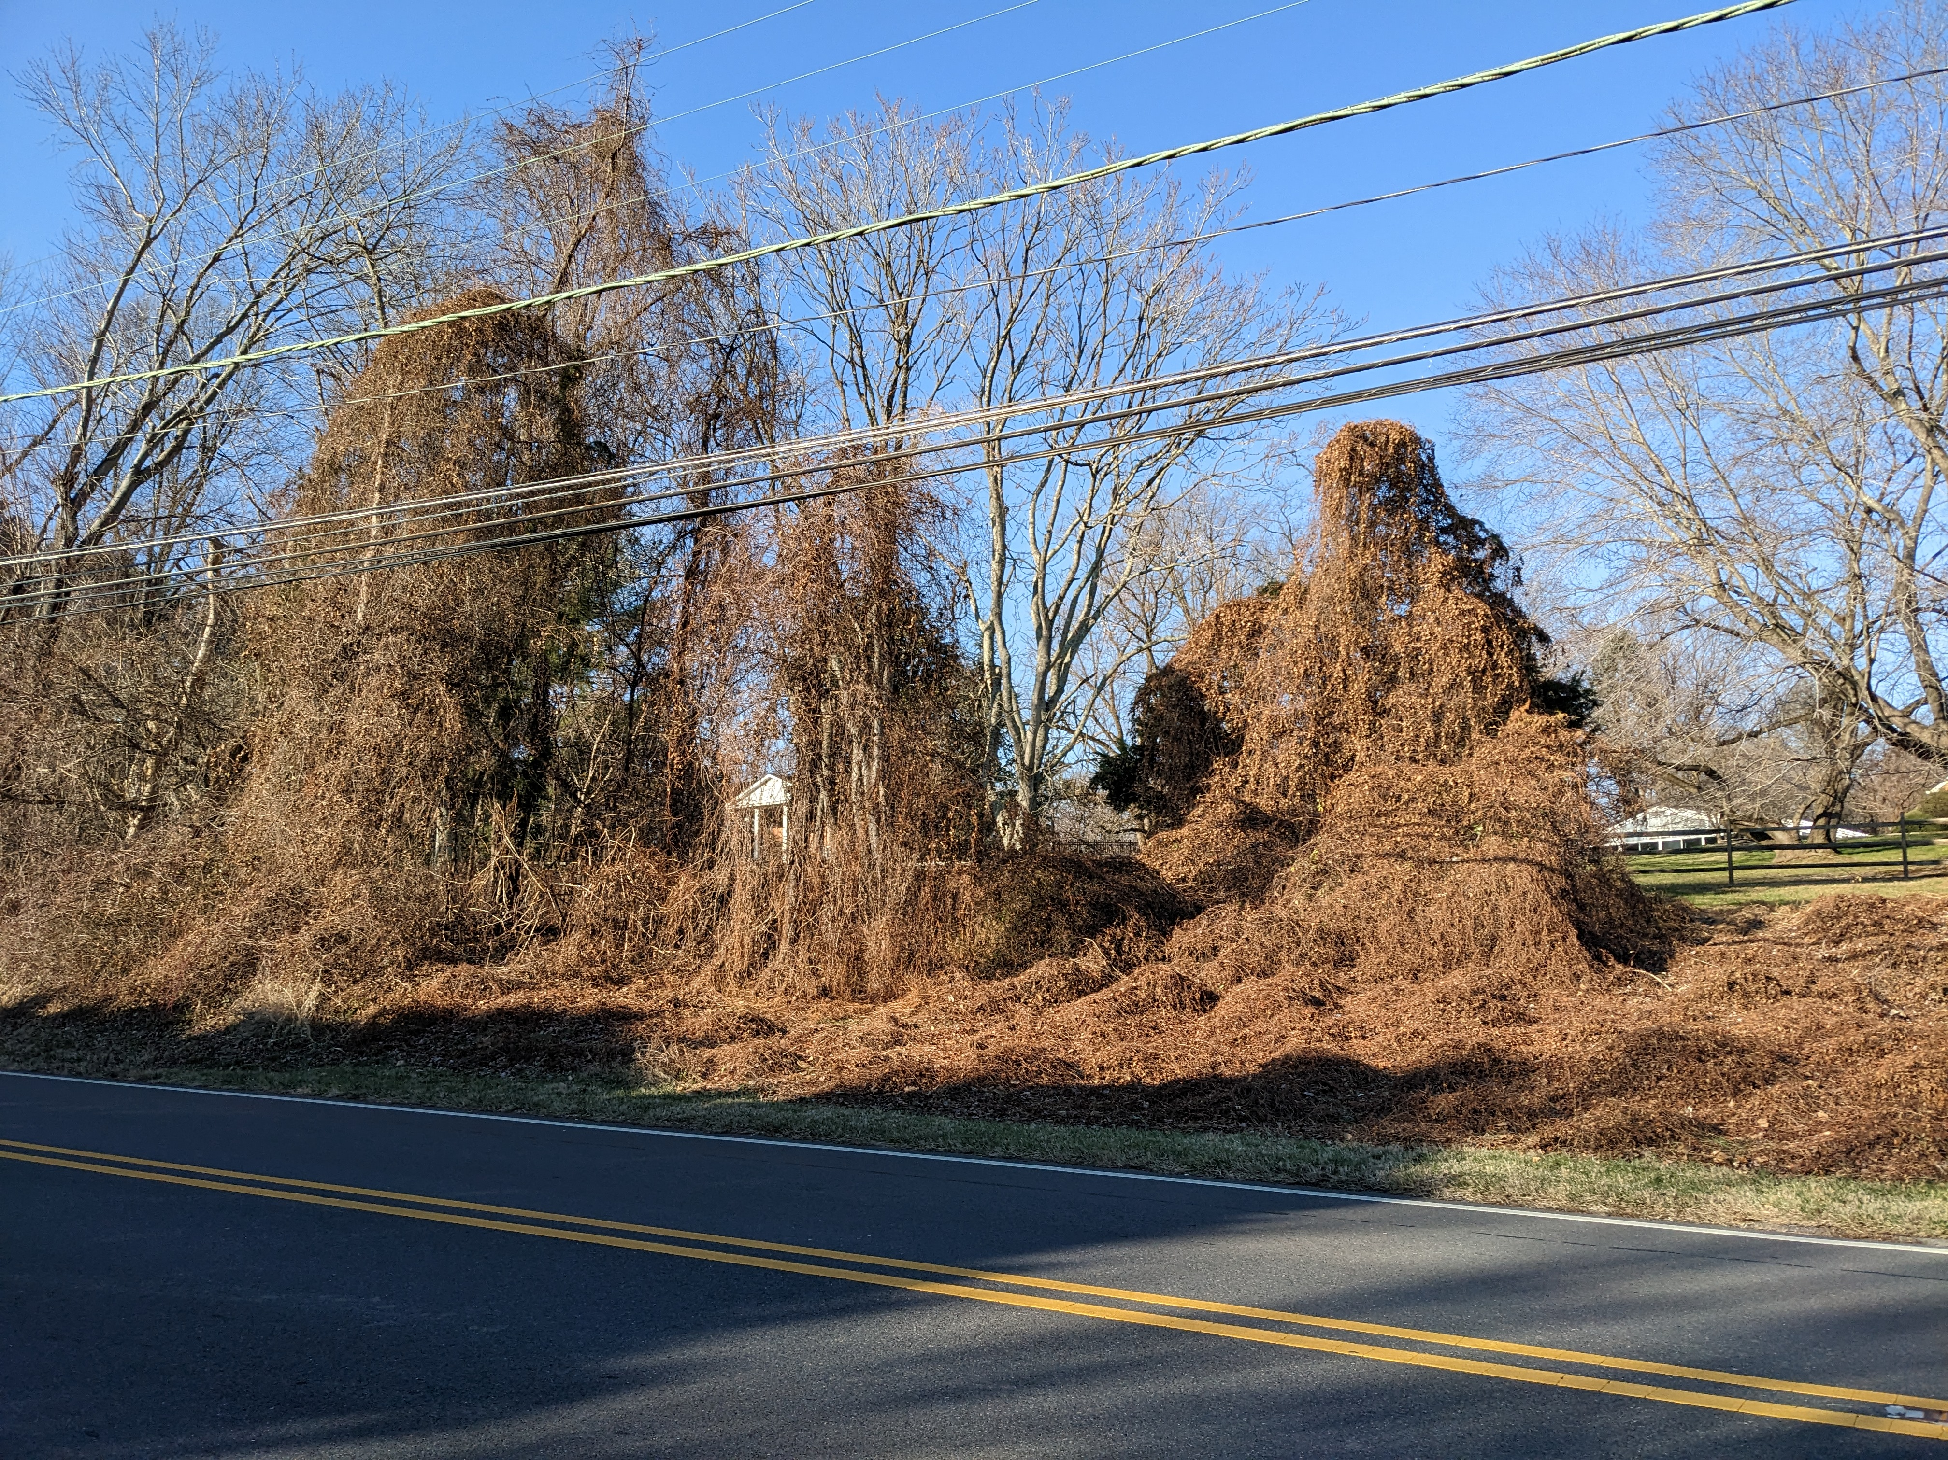Falls Road, Potomac, deciduous vine graveyard

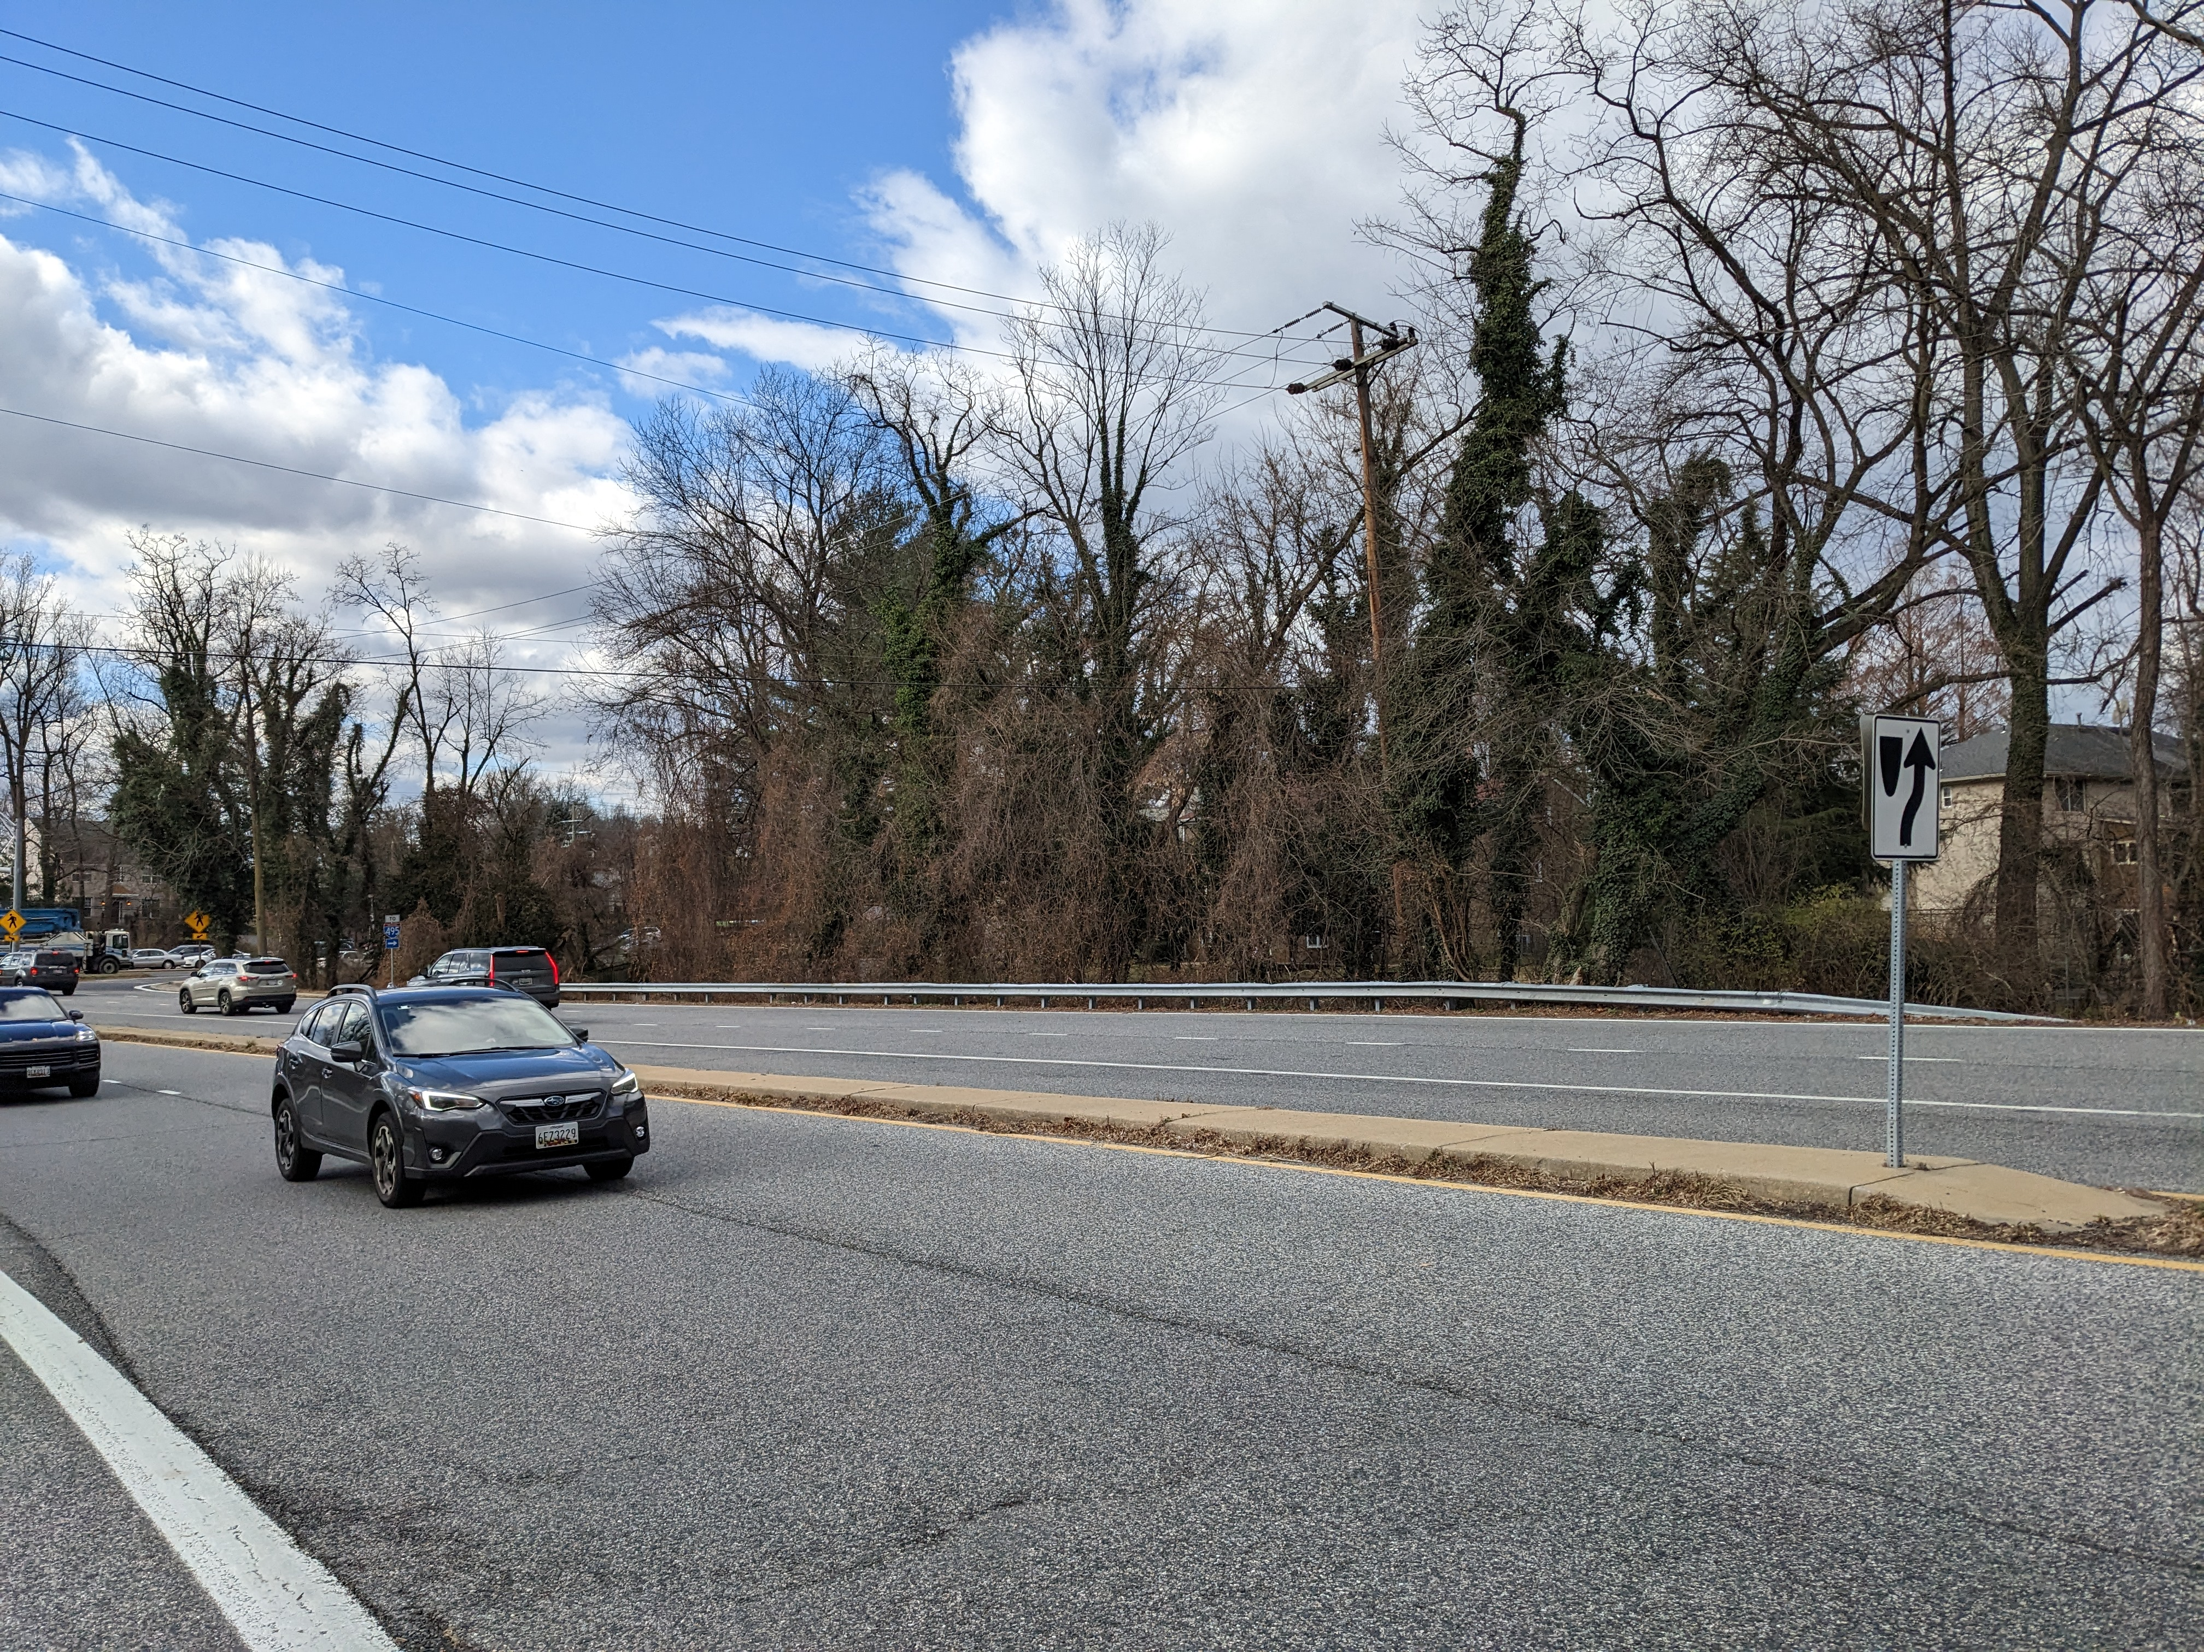Middle Lane across from Rockville Metro Station

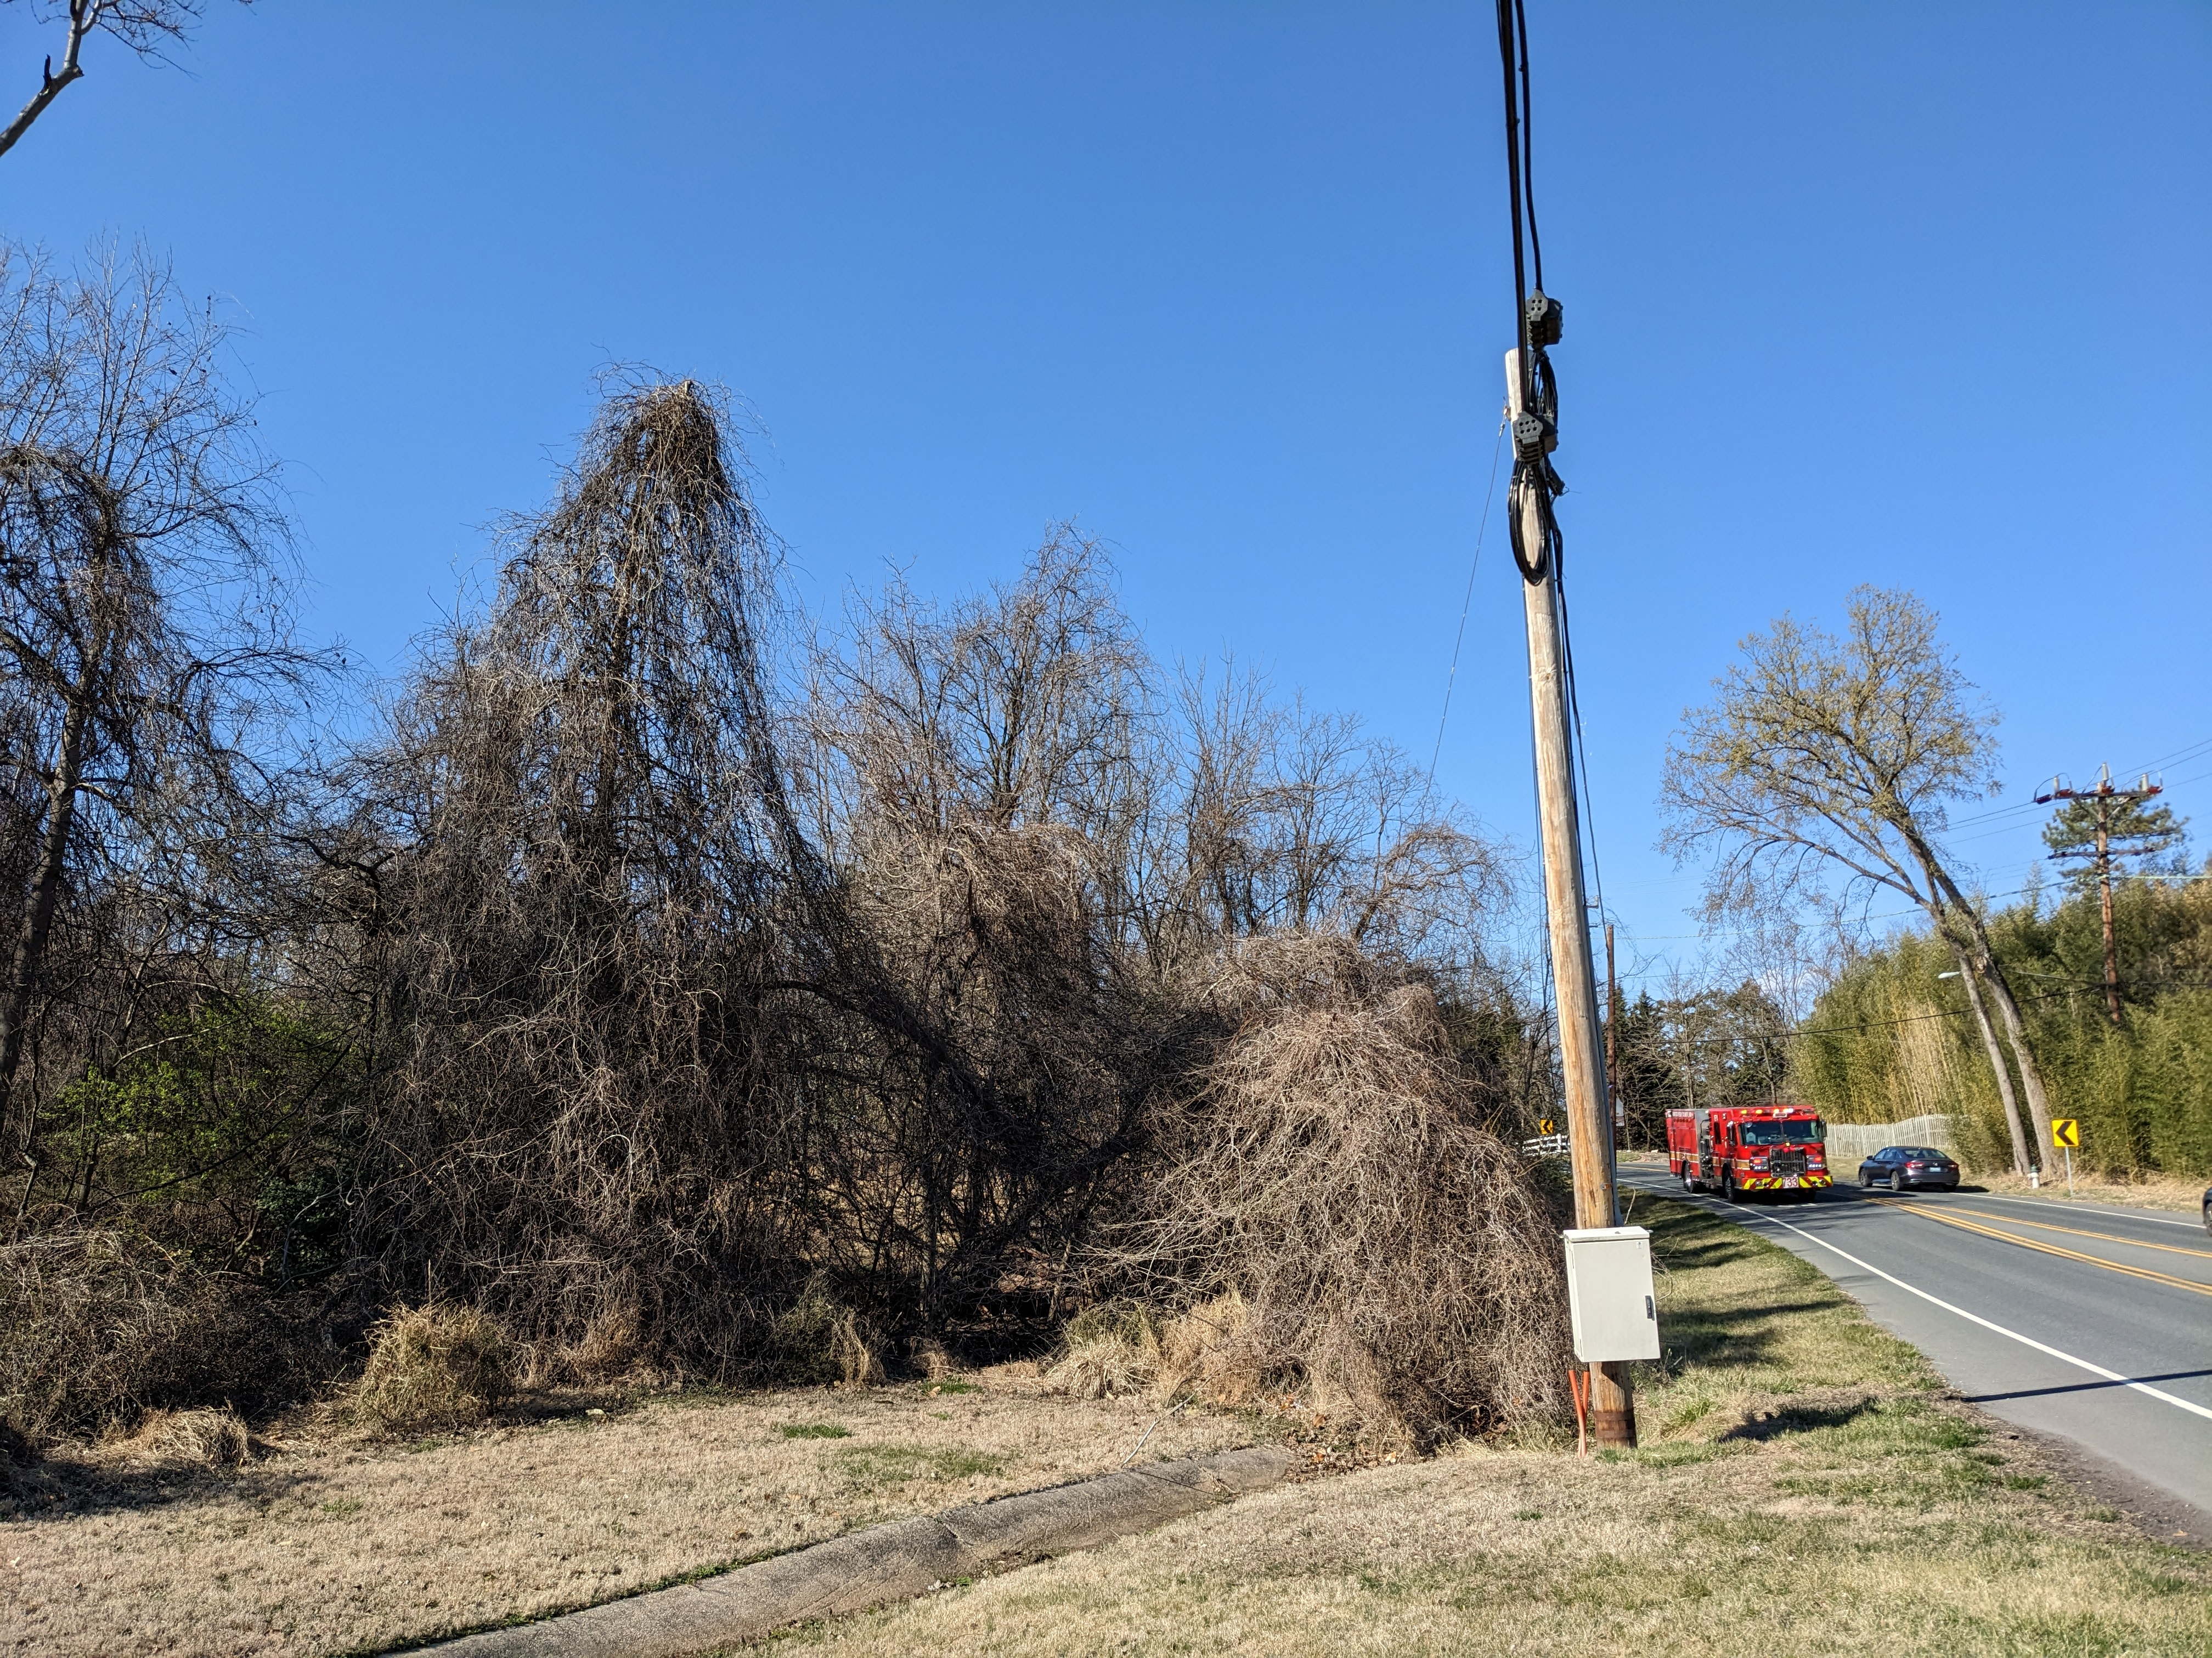Falls Road, Potomac, rescue service is too late to save these trees
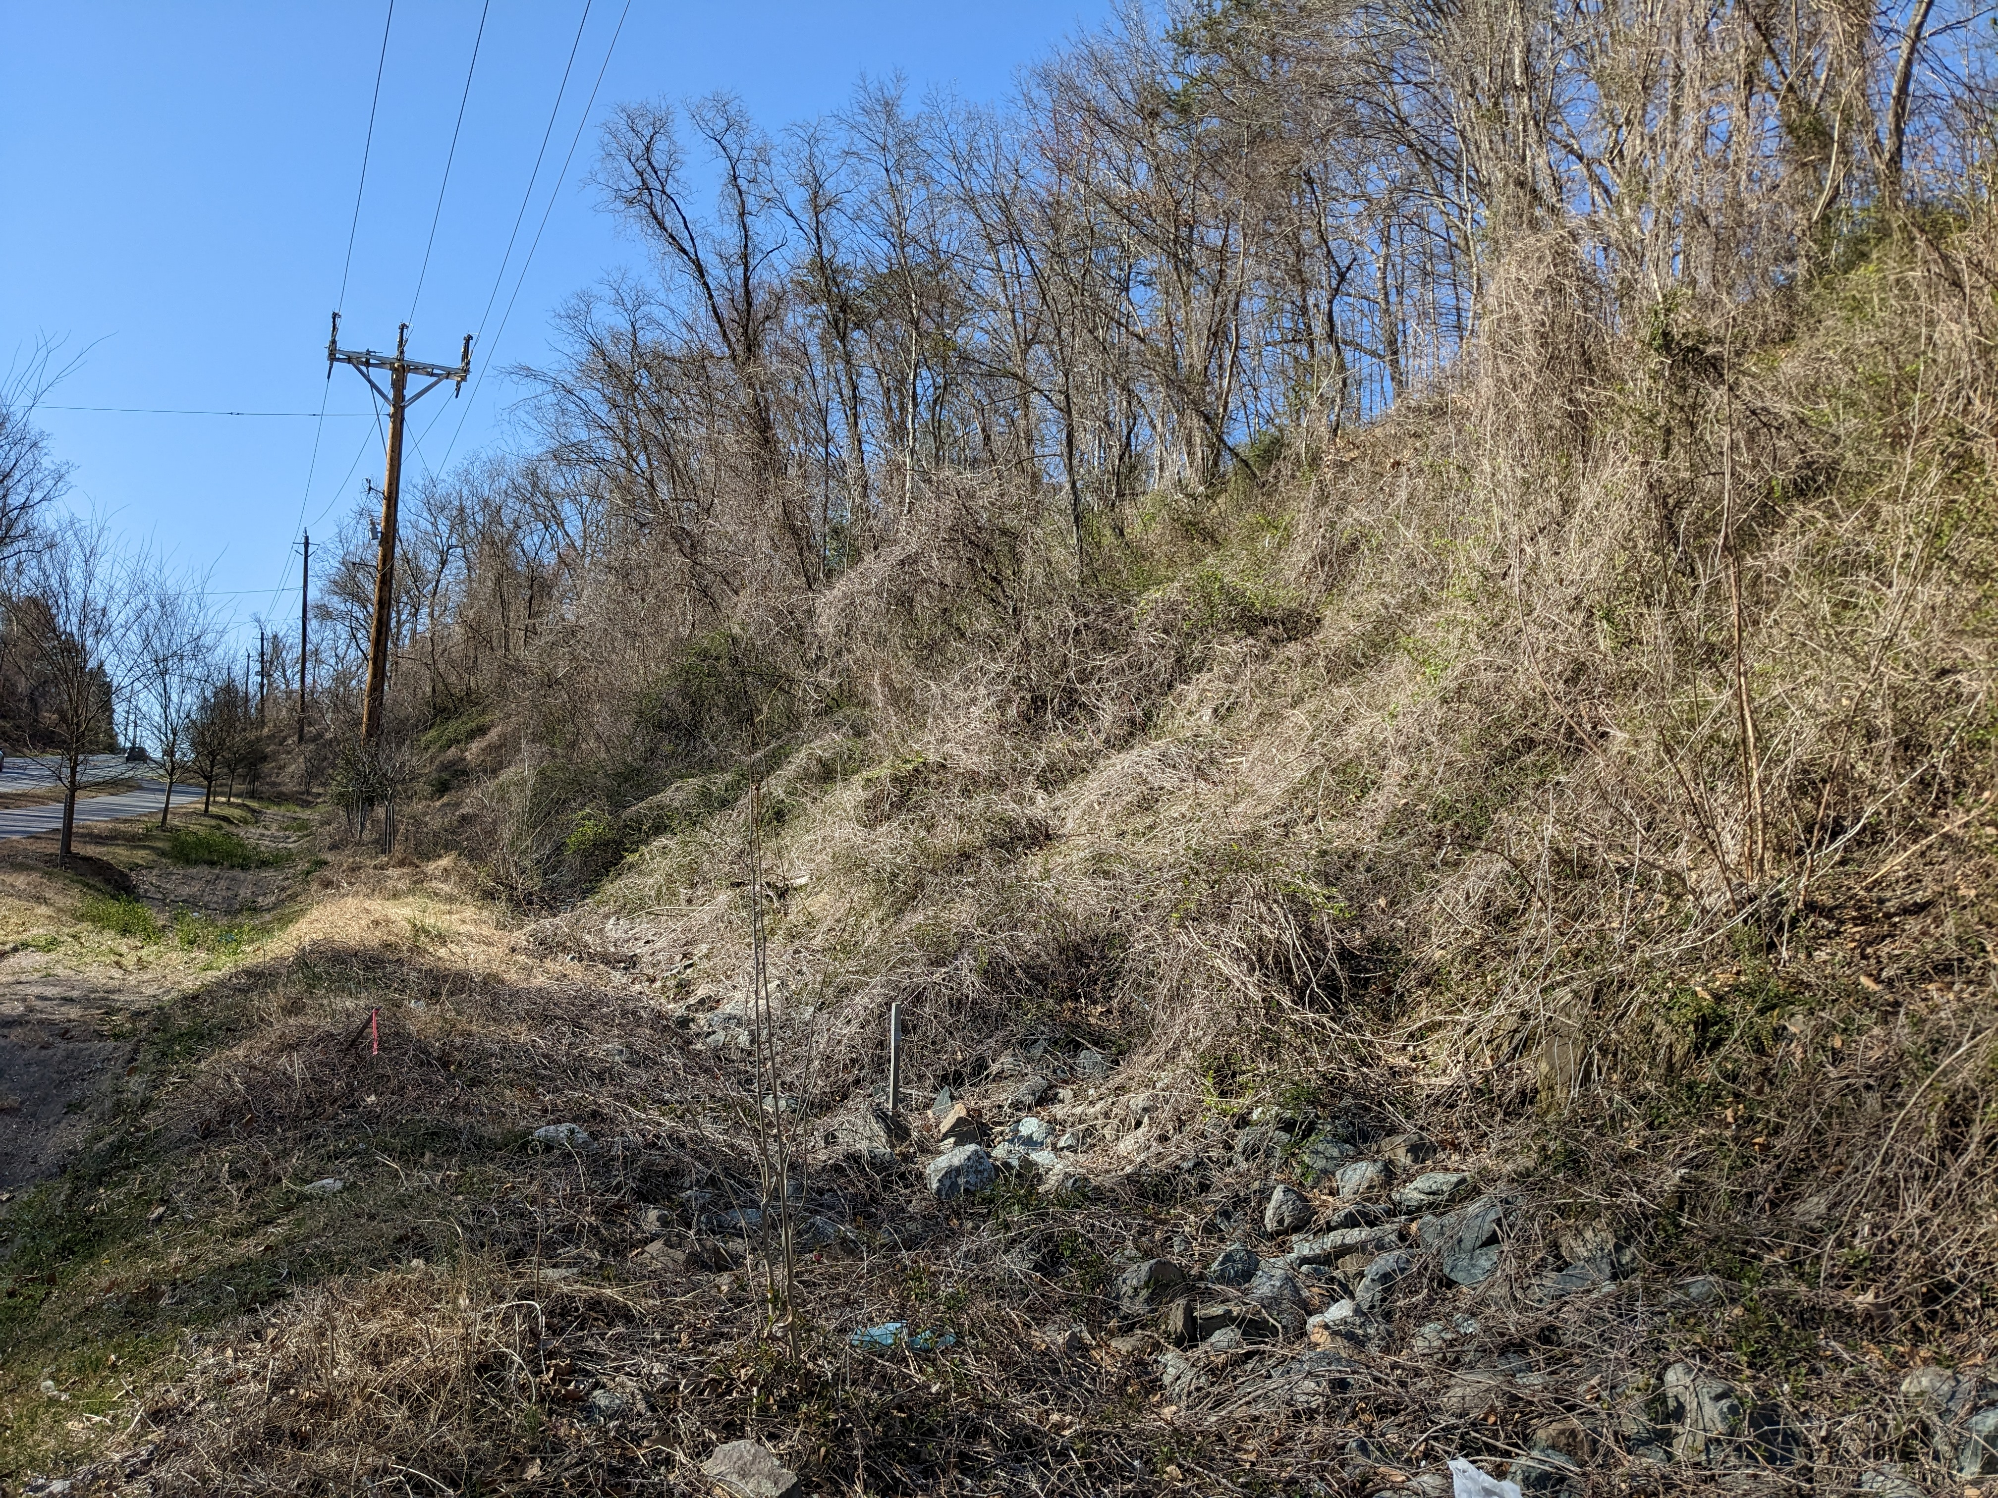River Road, Potomac, entire hillside swamped with vines starting up trees

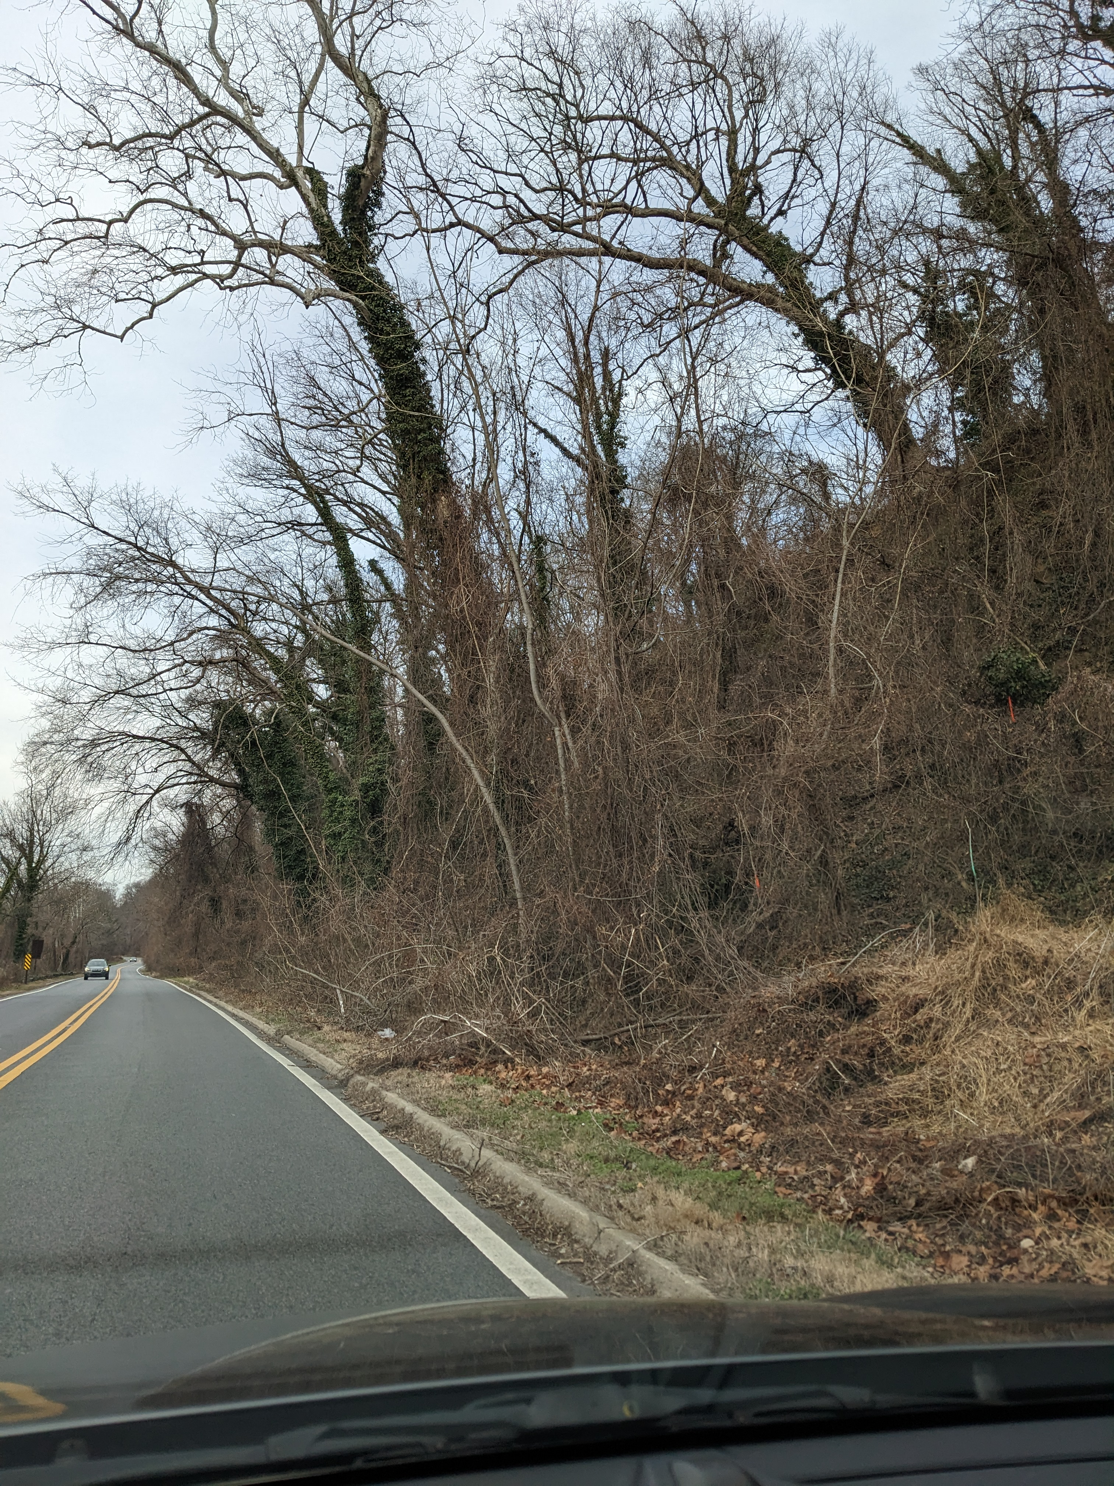Clara Barton Parkway, mixed evergreen & deciduous vines overwhelming roadside trees
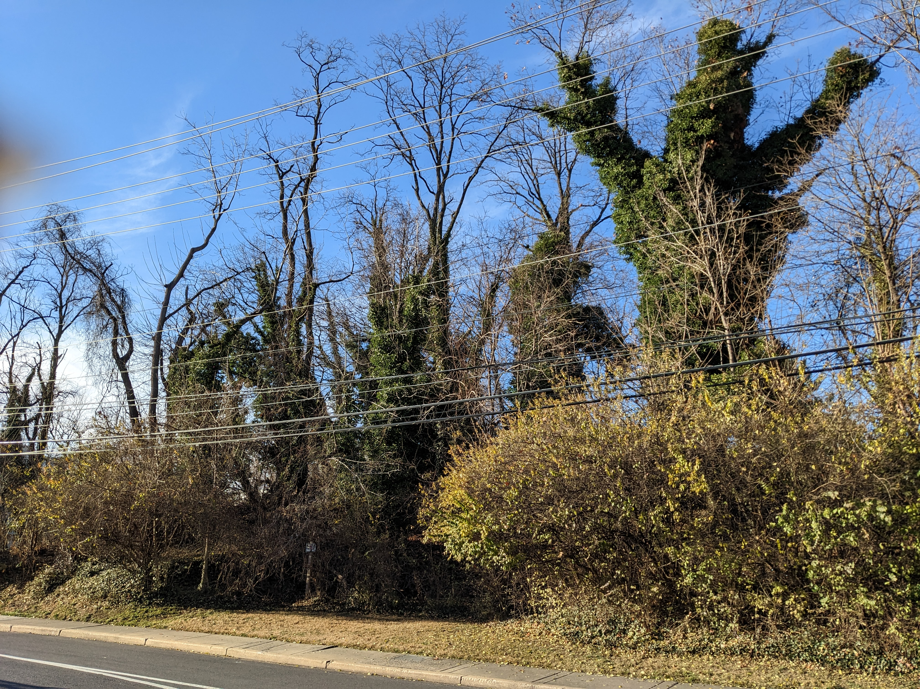Route 355, Clarksburg, grove of evergreen vines

The city of Takoma Park partnered with the Chesapeake Climate Action Network to train volunteers to eradicate vines from several thousand trees in the city’s parks. Montgomery County Parks Department runs a Weed Warrior program that uses volunteers to take out tree-killing vines in our parks. Where else should this be done? Along our roads where vines of many types are relentlessly overwhelming and slowly killing thousands of street trees.

DOT runs an Adopt-a-Road Program to keep our roads litter-free. This is very nice, but should it not be a much higher priority to save the trees, both young and mature, along our thousands of miles of roads? Many are already dead. If we do not eliminate this scourge, we stand to lose many street trees.

There is also a public safety aspect to this problem. A dead tree along a road may topple over at any time imperiling drivers and snarling traffic. I saw this recently when a vine infested, dead tree toppled over onto Canal Road in the District.

PROPOSAL

DOT should initiate a “Tree Hugger” or “Tree Savior” program using volunteers from a number of civic and conservation organizations.
- Montgomery County Civic Federation
- Audubon Naturalist Society / Nature Forward
- Sierra Club, Montgomery County Chapter
- Conservation Montgomery
- Maryland League of Conservation Voters
- My Green Montgomery
- Bethesda Green
- Chesapeake Bay Foundation
- Montgomery Countryside Alliance
- Potomac Conservancy
- Chesapeake Climate Action Network
- Rock Creek Conservancy
- Cedar Lane Ecosystem Study Group
- 350 MoCo
- Bethesda Green
- West Montgomery County Citizens Association
- Biodiversity for a Livable Climate
- Environmental Justice Team, Cedar Lane UU Church
- Green Sanctuary Committee, Unitarian-Universalist Church of Silver Spring
- Montgomery County Faith Alliance for Climate Solutions
- Takoma Park Mobilization Environment Committee
- Boy & Girl Scouts
- high school students to earn volunteer service hours
- When Governor Moore’s program to have high school graduates do a year of community service, these youths would make excellent workers, administrators and overseers to work with other volunteers

TRAINING
Because our priority should be saving the trees, we suggest using a short video training program that all volunteers can access in their homes and at their convenience. It should cover:
- safety for the volunteers working along the roadsides
- guidelines for working only in the public right-of-way
- a “How To” with visual demonstrations and tips for eradicating all vines on trees and the tools needed. Volunteers should not have to be trained to distinguish between native and foreign invasive vines.
- Tips on what to say if challenged by those wondering what they are doing.
- It is possible that training materials can be borrowed and edited from programs already in place

VOLUNTEERS should:
- Sign a “Hold Harmless Waiver” form exempting DOT from liability if a volunteer is injured while carrying out their assigned work.“DOT Tree Savior Warrior
- Wear simple, orange, plastic safety vests identifying them as “DOT Tree Hugger” or “DOT Tree Savior”
- Provide their own tools and equipment
- Carry a letter from DOT certifying them as a “Tree Savior” or “Tree Hugger” and spelling out what they can and cannot do.
- Possibly carry a letter (copies for distribution) from the County asking homeowners to eradicate vines on their own trees.
- Take photos of the trees they have liberated and provide data on the number of hours worked and trees saved.

TO BE DETERMINED:

The volunteers will be cutting the vines at or close to ground level and pulling them back from around the tree trunks. This will not, however, kill the vines, and they will come back. Over and over. To win the war in the long term, should the county undertake to kill the vines on the ground with herbicidal spray? If so, what department should be tasked with this responsibility? And what will the financial cost be?

